BUG REPORT OF AAJ TAK
APP: AAJ TAK
DEVICE : REDMI 6 PRO
ANDROID VERSION : 8.1.0
APP VERSION: 6.76
DOWNLOAD SIZE : 11.35 MB
[PORTRAIT MODE]
1.MODULE/PATH : Homepage
BUG: System does not redirect home page.
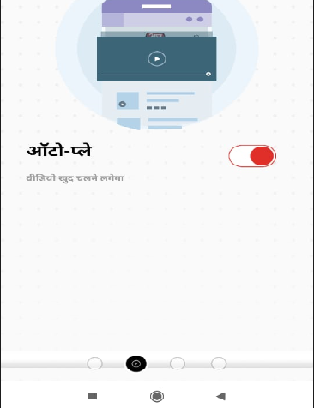
EXPECTED RESULT : System should redirect home page.
PRIORITY : Medium
2.Module : FEED BACK
BUG : When we enter mob number then alphabet key pad is open.

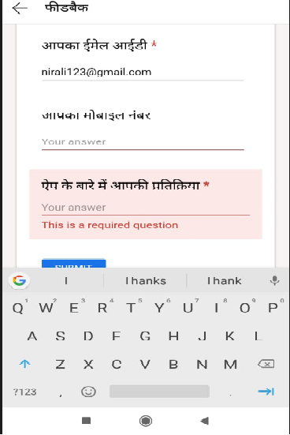
EXPECTED RESULT : Numeric key pad should open.
PRIORITY : Law
3. MODULE : FEED BACK
BUG: Max length allow for mobile no field.
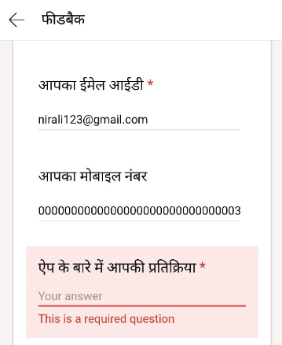
EXPECTED RESULT : Should not allow max length for mobile no field .
PRIORITY : High
4.MODULE : FEED BACK
BUG: Allow invalid format for mobile no field.
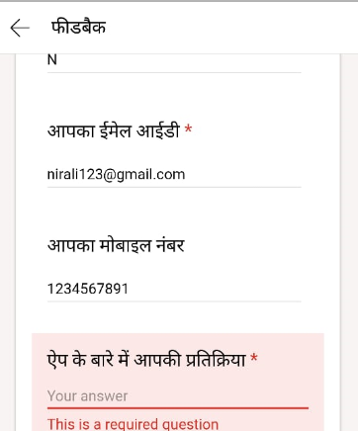
EXPECTED RESULT : Does not allow invalid format for mobie no field .
PRIORITY : High
5.MODULE: KARYAKRAM
BUG : In krantikari bahut krantikari is not fire message that “no news” like this.
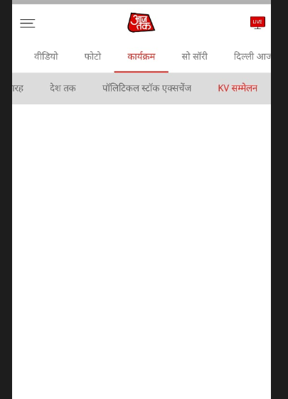

EXPECTED RESULT : System should fire validation message .
PRIORITY : Law
6.MODULE: POLITICAL
BUG : Pause button is not working properly.
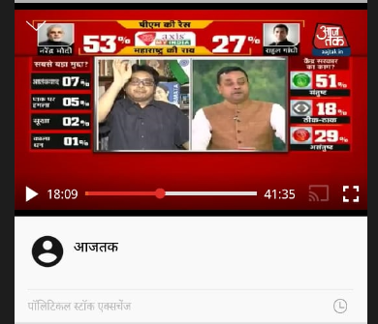
EXPECTED RESULT : Pause button should working properly.
PRIORITY : Medium
7.MODULE : POLITICAL
BUG : System is crash some time.
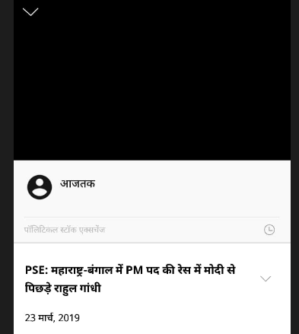

EXPECTED RESULT : System should not crash.
PRIORITY : High
8.MODULE : PHOTO
BUG :There is no close or cross symbol in ad.
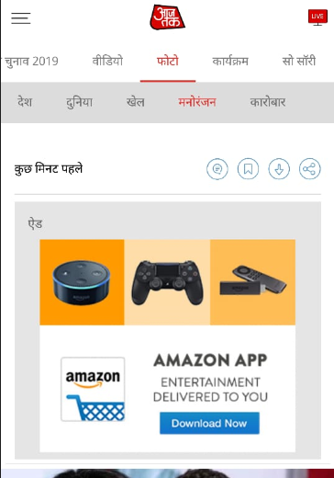
EXPECTED RESULT : System should show close or cross button for ad.
PRIORITY: Law
9.System is not working in landscape mode properly.

